UNDERGROUND STORAGE TANKS AND THE ENVIRONMENT

Timothy L. Crumbie, PG

PART TWO: USTS FROM A GEOLOGIC PERSPECTIVE

Many people still question the need to regulate underground storage tanks (USTs). Some contend that the regulations are just another way for the government to generate revenue while others refuse to accept the risks for exposure to petroleum contaminants. They often support their positions by stating that they have dumped waste petroleum products on the ground for years and have no adverse health effects.

Contamination does not affect all people in the same manner. Many constituents found in petroleum fuels are considered toxins and carcinogens. As such, they present a health hazard to humans, animals and the environment, even when released in small concentrations. Repeated exposure to elevated levels of contaminated air, soil or water increases the likelihood that a medical condition may develop, but it is not guaranteed. Too many variables are involved to allow an accurate prediction of who will be adversely affected by chemical exposures.

Petroleum products are composed of many compounds, most of which can migrate through the soil or bedrock and into the groundwater system. Groundwater spreads the contaminant plume as it moves down gradient. The larger the plume, the greater the potential for a domestic use water source to be impacted. This is significant because according to information obtained from the Kentucky Division of Water’s (KDOW) Web Page (http://www.water.ky.gov/gw/GWB-GW_awareness.htm), it is estimated that more than 1.5 million Kentuckians are served by 185 public water systems that utilize groundwater as their exclusive or partial drinking water source. Additionally, 415,950 rural Kentuckians not connected to public water systems are estimated to rely on private wells or springs for their drinking water. These figures do not include industrial and agricultural uses of groundwater. Polluted groundwater can also impact surface water bodies as groundwater often recharges streams, rivers and lakes.

The geologic setting of a site is important because it can have a profound effect on the dispersion of contamination. Soil depth and type, groundwater presence, bedrock type, and bedrock structures (bedding planes, solution features, fractures, etc.) are key elements that can minimize or exacerbate the effects of a spill or release from a UST system.

GEOLOGIC PROFILE AND PLUME MIGRATION

The Soil Profile

Soil is typically the first material a release contacts once it is free of the containment system and it can either inhibit or facilitate the distribution of a liquid. Generally speaking, compacted clay and silty clay are more likely to inhibit contaminant dispersion due to their low permeabilities. Permeability refers to the capacity for a porous medium (sediment or rock) to transmit fluids. Liquids tend to move relatively slowly through silts and clays as a result of small, interconnected pore spaces (interstices) between the individual soil particles. Conversely, liquids can move more readily through soils with larger interstitial openings such as unconsolidated sand. Groundwater movement through pore spaces is known as primary porosity and it applies to both soil and rock. Water moves through these openings from points of higher hydraulic head to points of lower hydraulic head (unless acted upon by an external force). It should be noted that that these aquifer characteristics can vary vertically and horizontally meaning that a contaminant may be able to travel more easily in one direction as opposed to the other (anisotropy).

When evaluating the soil profile, one should be aware that the surface of a property may have been re-graded, which could disrupt natural groundwater movement by creating preferred pathways. These pathways can exist as the result of differential compaction, cracks or interfaces between varying soil types. As an example, liquids tend to migrate preferentially along the interface between the former surface of the ground and the fill material that was placed above it; especially if the organic material was not removed prior initiating the grade work. The term secondary porosity applies when groundwater movement is controlled by natural or man-made structural features (exclusive of primary porosity). Primary and secondary porosities can exist collectively or independently of one another which could complicate the subsurface flow regime.

Groundwater

Groundwater is arguably the most important media to consider when assessing a site for contamination. Groundwater is water that naturally accumulates in the subsurface as a result of rain or melting snow. As referenced earlier, groundwater in Kentucky is widely utilized for domestic, agricultural and industrial purposes. Groundwater is also the primary mechanism of transport by which contaminants spread underground. If groundwater is not present or is located at great depths, chances are the impacts from a release will not migrate very far from the source (barring the presence of natural or man-made conduits).

Free phase hydrocarbons float on water and as a result, shallow groundwater will somewhat limit the vertical extent of impacts from liquid hydrocarbons to the area between the high and low points of the water table (smear zone). Conversely, the released fuel will more quickly enter a shallow groundwater system allowing it to disperse sooner than if the water table was deeper. If free product is floating atop a shallow or perched aquifer, the potential for vapor intrusion in utility trenches and neighboring properties is greatly increased.

Bedrock

The physical and chemical properties of differing rock types help define the hydrogeologic properties of the bedrock unit. Several types of sedimentary rocks are present across Kentucky with limestone being the most pervasive (>50%). Depending on location, a site could be underlain by limestone, shale, sandstone, siltstone, dolomite or Carboniferous deposits which are typified by alternating sequences of shale, sandstone and coal.

As with soil, the properties of any given rock type are not guaranteed to be uniform. Certain limestone formations contain a high percentage of the mineral calcite which can be dissolved by acidic groundwater. This process is known as solutional weathering or solutioning. Other types of limestone contain higher percentages of dolomite or shale which resist solutioning. Poorly developed primary porosity does not render a formation incapable of transmitting liquids. Secondary porosity developed as a result of solutioning or along bedding planes, joints and other structural deficiencies within the rock unit can also facilitate the transportation of liquids. These features allow rapid migration of groundwater and contaminants. A release from a UST system that would normally migrate on the order of inches per week in unsaturated conditions can travel miles in a single day through secondary porosity features, especially following a period of high precipitation. A UST owner/operator that has or had a leaking tank would bear the responsibility of remediating the entire area that has been impacted by the release. Figure 2 is a generalized block diagram showing karst (solutional) development in Central Kentucky.

This article represents the views of the author and does not necessarily reflect the views of the entire Kentucky Section of the American Institute of Professional Geologists (AIPG) membership

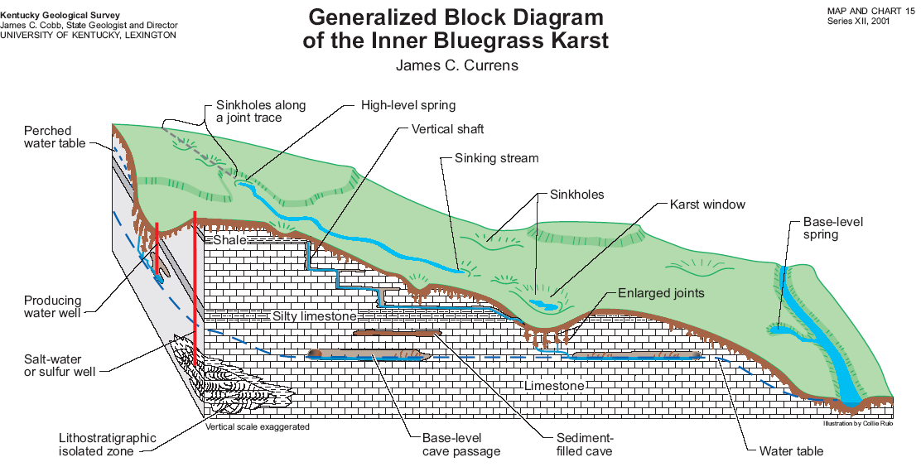
Illustration provided courtesy of the Kentucky Geological Survey.

Figure 2: Illustration showing various components of karst development in limestone found in Central Kentucky and how ground and surface water are incorporated into the system.

